**TEAM NAME :Stratton Oakmount**

**PROJECT NAME : *Labour Chauraha***

**TEAM MEMBERS:**

1. **Sahil Khanna**
2. **Aryan S Parekh**
3. **Anisha Mishra**
4. **Neel banga**
5. **Shashwat Rai**

**CONTENTS**

**1) Problem Definition**

**2) Solution**

**3) Progress till now**

**4) Any competitors in the market**

**5) USP of your project**

**6) User manual**

**7) Link to the GitHub files**

1. **UML diagram**
2. **Overall functionality**

**1)Problem Definition**

There are an estimated 139 million migrants in the country according to the World Economic Forum. The International Labour Organization (ILO) predicted that due to the pandemic and the lockdown most of these workers would be poverty-stricken. Many of them have lost their jobs. Due to the pandemic, people need to follow social distancing norms and for this, it is imperative that certain things need to be improved.

The labourers who have to meet at certain chowks (meeting points) for their employment are at great risk. To protect these daily wagers, what solution would be more apt than an electronic system between the workers and the employers.

**2)Modules**

2.1 AboutUs.php

This module directs to a page containing the details of the website.

2.2 index.php

This module creates a home page for the website where labourers can register by giving their employment details.

2.3 menu.php

This enables the navigation between different pages.

2.3 Lstorage.php

This module gets the employment details of labourer and stores them in MySQL database for the website.

There are two types of storage.

2.4 Jobseeker.php

Labourer enters his own details(Name, Aadhar, Phone Number, Start date, End date, Skills, Money) which gets uploaded in the our database.

2.5 Sender.php

This module sends SMS to the user's phone number.

2.6 OTPget.php

This modules accepts OTP that was send to the phone of the labourer.

2.7 OTPcheck.php

This module verifies OTP.

2.8 Lstorage.php

Labourer's info gets stored in sql.

2.9 Employer.php

Employer enters employer's details(Name, Aadhar, Location, PhoneNumber).

2.10 Sender2.php

This module sends SMS to the user's phone number.

2.11 OTPget2.php

This modules accepts OTP that was send to the phone of the labour.

2.12 OTPcheck2.php

This module verifies OTP.

2.13 Estorage.php

Labourer's info gets store in sql.

2.14 checkbox.php

Shows the list of the labourers in employer's location. The employer can choose the labourers accordingly.

2.15 selectionsms.php

This sends msg to all the labour that was chosen in check box.

2.16 CSS

There are three CSS files that enhance the beautification of the website.

2.17 transfer.php

The information of the labourers which were selected by the employee are transferred to selected and their data are deleted from their original database.

2.18 chat files

A few php and css files enable the chat option which includes login.php, chatpage.php chat.sql table and more.

**3)Solution**

To address this gaping need we are aiming to develop a website which incorporates simple registration, selection of workers. Here workers can register themselves with a simple OTP service and then the employers can eventually select them based on their skill and pay for a specific location.

We are creating a platform where labour and employers can come in contact and make their lives a little easier. Therefore, by providing more employment opportunities to the labour we can potentially increase the overall wage of the labourers.

As we have recently seen in the current pandemic, the lack of databases for migrant workers/daily wagers has caused major problems for them. These people who have recently been able to access the internet have an acute need of a network to enable hiring. Such a database would allow the government or any other organization to greatly assist in the future when such dire needs arise.

An electronic system such as this would reduce the contact between people and hence make them much more safer against disease and is a much more efficient and safe way. As we are not only planning to incorporate mobile OTP verification but also Aadhar verification.

It is important to collect comprehensive migrant worker-related data and statistics as proven by the current pandemic. Its absence had blindsided all on the scale of the migrant labour challenge and frustrated their efforts to reach them to help with food, cash, health services, shelter or relocation to home/host state.

The information asymmetry faced by poor migrants caused a lack of relief, benefits and transport needs to be addressed. Many became prey to disinformation, unscrupulous touts and motivated panic-mongers. Well-functioning hotlines, outreach systems and providing low-cost smart phones and IT education are crucial.

**4)Any competitors in the market**

There are no direct competitors for us in this market. There are companies that have similar job portals, but they exist for educated employees and higher pay individuals. While our site is dedicated towards daily wagers.

**5)USP of your project**

Our project is unique because ours is an untapped market-base as most of them have just received access to the internet but also sadly people have always paid less attention where such low wages are involved. Also, we are trying to make India better prepared for such future crisis as electronic methods reduce physical contact between people and enable quick proceedings.

**6)User Manual**

Steps-

6.1)Enter the website through XAMPP.

6.2)Click Job seeker, enter labourer details and click store.

6.3)An SMS will be send to their phones on the registered number for confirmation through OTP.

6.4)All the records will be stored in our the labourer table of our database.

6.5)Labourer has to wait till an employer selects them from the list.

6.6)The records of the selected labourers will be transferred to selected table.

6.6)Employers must enter their details by clicking on the employer button and click store.

6.7)An SMS will be send to their phones on the registered number for confirmation through OTP.

6.8)All the records of the employers will be stored in our employers table in the database.

6.9)Employer then can check the details of all the labourers who registered at his location.

6.10)Employer can now select any of the labourer.

6.11)All the selected labourers will get messages to their respective phone numbers.

**7)link to the GitHub files**

https://github.com/Stratton-Oakmount/LabourChauraha

**8)UML Diagrams**

**8.1 Use Case Diagram**

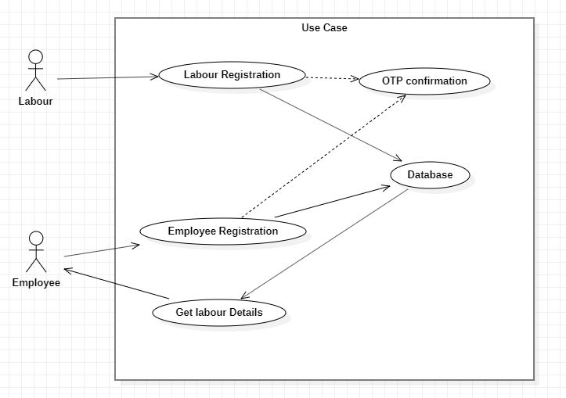

**8.2 Data flow diagram**

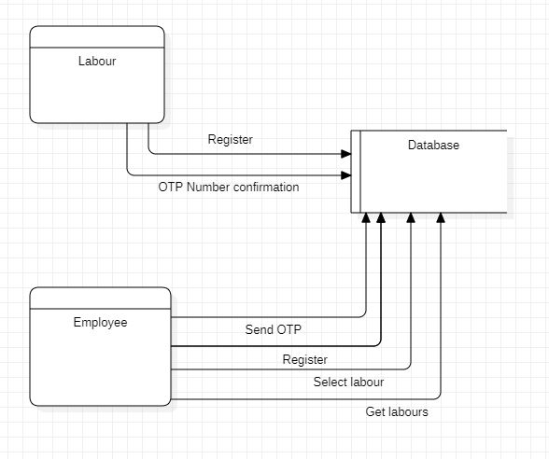

**8.3 Communication diagram**

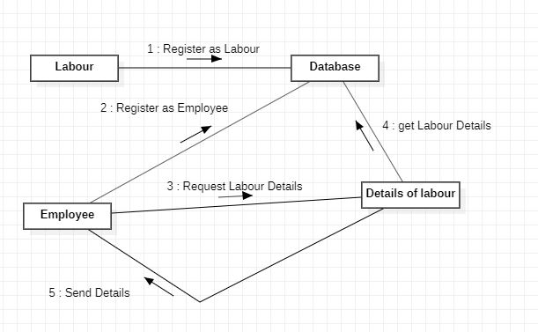

**9)Overall Functionality**

On this site both labourers and employers have to enter their details which gets validated through an OTP. Once the number is validated, the labourer details is stored in the labourer table and the employer details are stored in the employer table(Name, Aadhar, Location, PhoneNumber) in the database. Once the employer has stored his/her details, then he/she can see a list of labourers who have specified matching location in their job requirements. The employers can then select labourers from the list based on their skill requirements and pay. A confirmation SMS will reach the selected labourer/s with the details of the employer who has hired them.